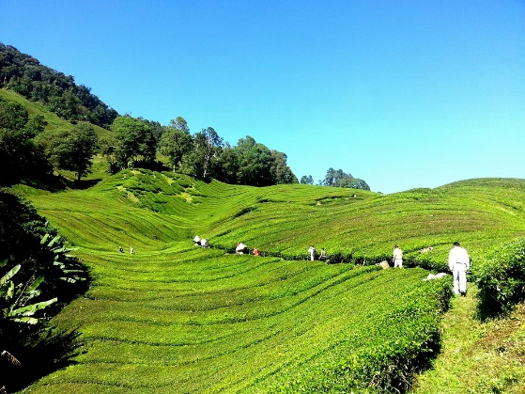
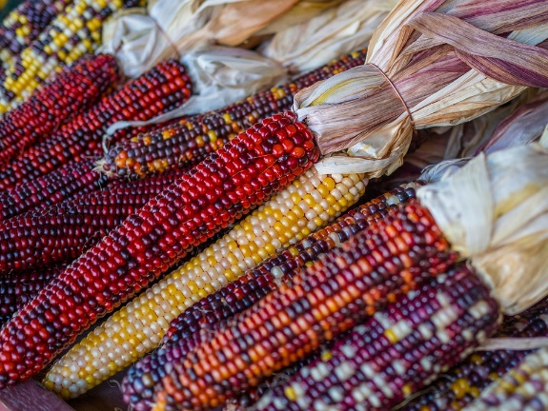
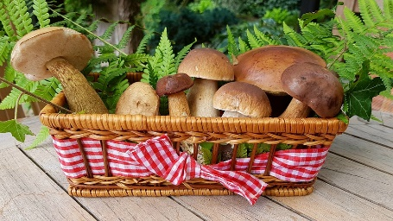

The Food Conscious Guide

a Guardians Worldwide guide to supermarket accountability, agricultural deforestation and the water-carbon footprint of food

What to eat, where to buy



Prepared by Guardians Worldwide for participants of ‘The Giving Course’, with Vandana Shiva
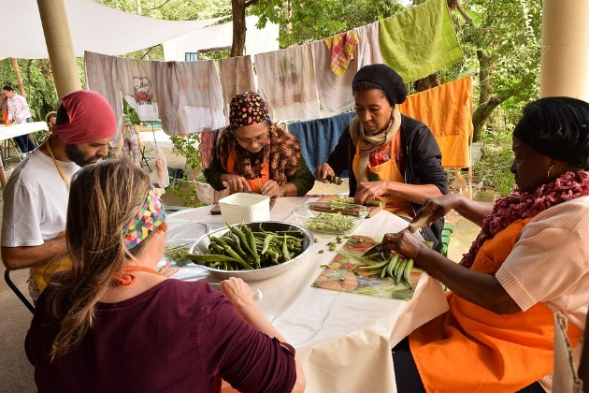

Introduction

Supermarkets are major contributors to global food insecurity, monopoly of food production/supply, indirectly through supply chains, destruction of subsistence forms of farming (e.g. indigenous, traditional, family, Afro-descendent). Big supermarkets are also drivers of monoculture, commodification of food and three major environmental problems:

- Deforestation
- Plastic crisis
- Carbon-water footprint

Read this report for a detailed ethical supermarket report by Ethical Consumer in the UK.

Deforestation

Did you know that some 80% of global deforestation is a result of agricultural production, which is also the leading cause of habitat destruction. Animal agriculture — livestock and animal feed is a significant driver of deforestation, and is also responsible for approximately 60% of direct global greenhouse gas (GHG) emissions.

Deforestation of the world’s primary forests—the Amazon, the Equatorial forests of Africa, the Atlantic Forest of South America, the forests of Southeast Asia, is a problem that is hidden within supply chains fuelled by major US, UK and European supermarkets.

Supermarket products that most drive deforestation, and which you must cut consumption of, are:

Soya: used for chicken feed and soy sauce mainly, it is causing the destruction of the Amazon and Atlantic rainforests in South America. Read this WWF report on why Nature itself is threatened by consumption and production of Soy, and why you must cut on its consumption. Also, watch this documentary by Guardians Worldwide contributor Aldo Benitez, entitled The Curse of the Atlantic Forest

Palm oil: used for numerous products, especially cookies, chocolates, shampoo, lipstick,
among others. It is causing the destruction of Equatorial rainforests in Africa and destruction of rainforests across Southeast Asia. Read this WWF report on why Nature itself is threatened by consumption and production of Soy, and why you must cut on its consumption. See also our appendix: How to cut on palm oil consumption.

Timber: used for numerous products and construction, it is the cause of deforestation
Worldwide, and also to blame for the replacement of ancient growth for plantation
and commercial forestry, which causes major loss of biodiversity (i.e. eucalyptus,
Sitka spruce, pine plantations)

Plastics

According to Greenpeace UK and the Environmental Investigation Agency (EIA), UK supermarkets produced 896,853 tonnes of plastic packaging in 2019 – roughly the equivalent of the weight of 90 Eiffel Towers.

Consumers can continue to pressure brands and supermarkets to reduce plastic packaging. Already, nearly half of consumers aged 18-34 say they have changed food brands based on packaging.

This guide will help you avoid plastic waste during your weekly supermarket trip.

Carbon footprint

‘Eating local’ is a recommendation you hear often – even from prominent sources, including the United Nations. While it might make sense intuitively – after all, transport does lead to emissions – this is one of the most misguided pieces of advice.

Eating locally would only have a significant impact if transport was responsible for a large share of food’s final carbon footprint. For many foods, this is not the case.

GHG emissions from transportation make up a relatively small amount of the emissions from food. What you eat is more important than where your food travelled from.

Land use, farming and animal feed is what produces most of the carbon.

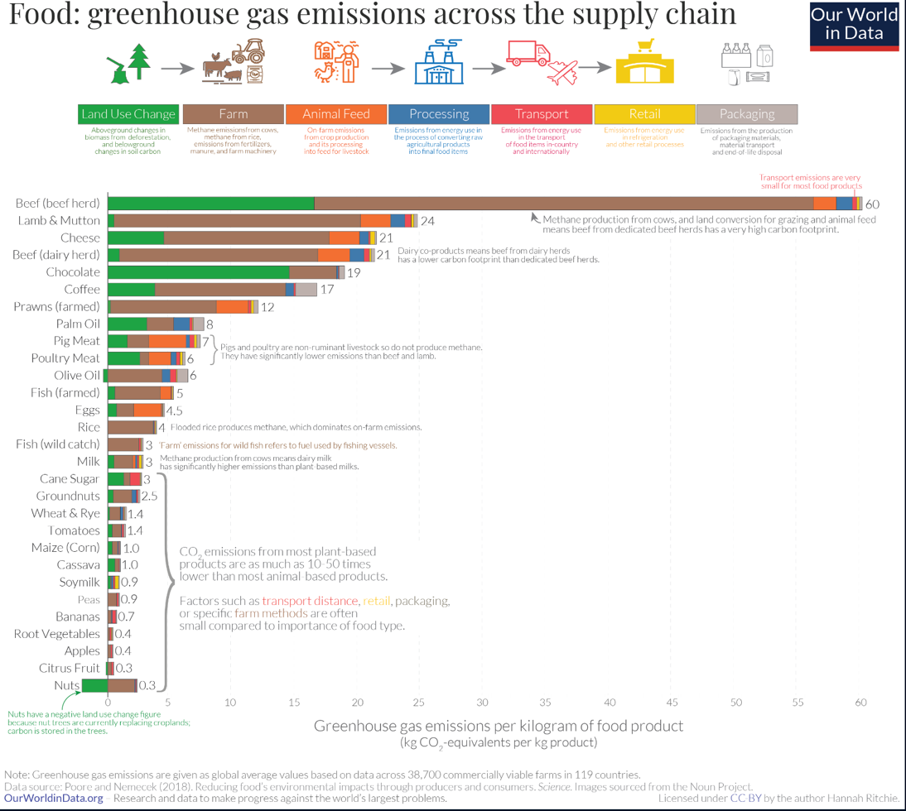

Water footprint

You must also consider the impact food has on water use, water stress and water injustices around the world. There are many serious examples of food commodities associated with extensive water use and water footprint.

Here is our list of the 10 most serious examples of water intensive crops, causing major water stress:

- Avocado- Top of the list is avocado, causing major water crisis in Mexico, Chile and Israel. 1kg of avocado= 1000 litres of water. Here are 7 problems associated with the avocado boom.
- Almond: Produced for food and milk. Did you know that California’s Almonds Suck as Much Water Annually as Los Angeles Uses in Three Years? Read on
- Sugarcane: sugarcane is a water-consumptive crop, driving lands used for their plantation into drought in many parts of the world. Here is a Third Pole report on sugarcane and its impact on water stress.
- Wine: grapes are also water-intensive crops that grow on dry and sunny lands. Vineyards in California, Chile, Argentina and other wine producing countries are drying up rivers and groundwater aquifers causing water stress. https://www.theguardian.com/food/2022/sep/20/droughts-heat-and-fire-the-future-of-wine-in-the-climate-crisis
- Tea- water consumptive crop under strain due to drought in many parts of Asia. https://www.theguardian.com/environment/2010/dec/26/climate-change-assam-tea
- Rice: Here is a BBC report on the enormous amount of water required to produce rice, and how drought resistant grains can help improve water stress.
- Coffee: high demand of this commodity is threatened by drought and water scarcity in many parts of the world where coffee is grown (tropical high altitude).
- Milks: the carbon footprint and water footprint of milk is very high. It is hard to tell which milk is most environmentally friendly, because while cow milk has a very high carbon footprint, the same applies to soy milk, alternatives like almond, oat and rice milk are low on carbon footprint but high on water footprint.

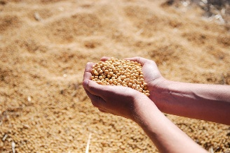

Check the Water Footprint calculator to check how much water is in your food.

Read the Water Footprint of Food for more details

Supermarket accountability (UK)

Supermarkets fail to deliver on social justice and environmental sustainability. Here is our ranking of UK supermarkets records on plastics and deforestation, based on existing research from various organisation including The Guardian, Mighty Earth, Greenpeace, Client Earth, and our own evidence and experience.

Supermarkets are responsible for creating food supply chains with food growing and producing companies that source key commodities. Unethical sourcing means that supermarkets often support, directly or indirectly, legal and illegal deforestation of primary forests.

In the UK and US especially, supermarket policy on single use plastics is appalling.

We have ranked the supermarkets from most environmentally friendly to least environmentally friend, according to the following categories, based on online available data:

Ratings: Excellent, Good, OK, Not Enough, Bad and Awful.

CO-OP

The company received Ethical Consumer’s best rating for Carbon Management and Reporting, Timber Sourcing, Toxic Chemicals and Environmental Reporting. It received a middle rating for palm oil sourcing, because although it sources most of its palm oil from physically certified supply chains, it doesn’t publish an annually updated grievance list or publish a list of all its mills and producer groups. A January 2021 Greenpeace report, ‘Checking Out On Plastic III’, tracked the progress of 10 UK supermarkets and ranked them on plastic usage. The Co-op was found to have the third-lowest plastic tonnage per unit of market share. Although Co-Op also received best ethical consumer ratings for cocoa supply it is linked with bad worker conditions in its tea supply in Kenya.

Impact on Deforestation: OK
Policy on Plastics: OK

WAITROSE

Second in our ranking is Waitrose. It is committing to reducing plastic and was the first UK supermarket to introduce soft plastics. Their pledge is for 100% of their own-brand packaging to be “reusable, widely recyclable or home compostable by 2023”. With Sainsbury, Waitrose is investing in deforestation free soy production in Brazil, and it is committed to zero deforestation.

Impact on Deforestation: Not doing enough
https://www.edie.net/tesco-waitrose-and-sainsburys-back-11m-initiative-to-tackle-soy-led-deforestation/
Policy on Plastics: Not doing enough
https://retailtimes.co.uk/new-uk-based-soft-plastic-recycling-available-at-waitrose/

MARKS AND SPENCER

This supermarket is cutting soya from its milk to end deforestation, it sources palm oil and soya responsibly, and also sources wood responsibly. Its deforestation policy is very clear and committed, yet the supermarket has an awful policy on plastics and packaging.

Impact on Deforestation: OK
https://www.theguardian.com/environment/2020/sep/30/marks-and-spencer-cuts-soya-production-milk-deforestation

Policy on plastics: Awful
https://www.dailymail.co.uk/news/article-10275275/M-S-condemned-sending-items-mountain-plastic-vows-UKs-greenest-shop.html

https://www.telegraph.co.uk/news/2022/02/04/ms-makes-underwhelming-progress-cutting-plastic-packaging-use/

TESCO

Sources its food irresponsibly, has a link to deforestation and mass forest fires in the Amazon via its poultry and pork chain supply, has done very few campaigns to reduce plastic, and misleads its consumers about its products. Tesco was the first supermarket to vow to stop plastics in wet wipes after it was criticised for its record- it still needs to deliver on its promise to cut down on plastics.

Impact on Deforestation: Awful
https://www.mightyearth.org/wp-content/uploads/Tesco-A-basket-full-of-problems-report.pdf

Policy on plastics: Not doing enough

ASDA

Asda is the worst. Its soya supply chain has been linked to illegal deforestation. Plastics and packaging is still a major sticking point for Asda. There is no clear policy on environment, and the company is linked to fossil fuel company TDR, which runs fuel stations across Europe.

Impact on Deforestation: Awful
Policy on Plastics: Awful
https://retailtimes.co.uk/new-uk-based-soft-plastic-recycling-available-at-waitrose/

Check The Ethical Consumer website for more details of these and other supermarkets around the world.

Can you produce a similar list for supermarkets in your country, where you live (if not UK)?

Overview of supermarket accountability

Our verdict is that supermarkets in the UK, the same applies in other countries, take a dubious approach toward environmental action by focusing either on deforestation policies or plastic, but not both, thus committing only partially to change. Supermarkets are not doing enough.

What is more, given the rise in food prices due to inflation, supermarkets are being accused of profiteering. This applies both to climate change policy and economic downturns, as supermarkets are clearly prioritising profit over planet and people.

It is important to avoid supermarkets as much as possible, and boycott supermarkets associated with deforestation, single use plastic, unethical sourcing of crops and bad labour practices.

Here are some social media hasthags that you should follow to learn more about how to boycott supermarkets, and how to connect more with local farmers, local markets and local produce

#boycottsupermarkets#boycottamazon #boycottwalmart #boycottsupermarkets #boycottsupermarchés #boycottgoogle #ecosia #buylocal #bikelife #onenation #buylocal #shoplocal #brightonbusiness #sacredeconomics #permaculture #community #comunaliving #socialjustice
#supportsmallbusiness #supportfarmers #supportfarmersmarkets #supportorganic #fertilityfoods #fertilitydiet #fertilitynutritionist

@foodbabe in Instagram useful as well.

Alternatives to supermarkets

There are many alternatives to buying food in supermarkets, for instance Riverford, Abel and Cole, HISBE, Planet Organic (UK based). Read this webpage from The Ethical Consumer for a comparison of these food networks.

This supermarket guide also includes details of, and links to, alternatives such as:
- independent wholefood shops
- zero waste shops
- wholefood retailers e.g. Suma (which included in the guide) but others are available
- food box schemes
- farmers' markets
- Open Food Network
- Community Supported Agriculture (CSA)
- Community growing and home-grown
- Sustainable Food Places
- Better Food Traders

Major food companies linked to environmental issues

It is also worth familiarising yourself with major food production companies and food suppliers, and their impact on deforestation and carbon emissions. Here are the three companies often labelled the worst companies in the world for food-related environmental destruction.

- Cargill, named the worst company in the world for its industrial production of soya

https://www.mightyearth.org/wp-content/uploads/Mighty-Earth-Report-Cargill-The-Worst-Company-in-the-World-July-2019.pdf

- Monsanto is frequently named the most hated company in the world for clearing forests around the world to plant genetically modified crops, especially soya. It has an appalling record of toxic contamination.

- Coca-Cola is world’s worst plastic polluter for fifth year in a row

Here are other household companies linked to deforestation through their demand for palm oil” Colgate-Palmolive, General Mills, Hershey, Kellogg’s, Kraft Heinz, L’Oreal, Mars, Mondelez, Nestlé, PepsiCo, Reckitt Benckiser and Unilever

https://www.greenpeace.org/international/press-release/18485/greenpeace-investigation-wilmar-brands-palm-oil-deforestation-indonesia/

Food labelling: how you can start to gain awareness and control

You have power and agency in the way you buy. How you buy, is similar to how you vote. You express a preference that has, when all votes or purchases are counted, a great impact on major companies and corporations, on their decision making and corporate social responsibility strategies, which are always responding to customer and consumer purchase behaviours.

Food labelling is one way in which you can gain control of what you eat, and how you can cast your vote.

According to FAO, a food label, the information presented on food product, is one of the most important and direct means of communicating information to the consumer. The internationally accepted definition of a food label is any tag, brand, mark, pictorial or other descriptive matter, written, printed, stencilled, marked, embossed or impressed on, or attached to, a container of food or food product. This information, which includes items such as ingredients, quality and nutritional value, can accompany the food or be displayed near the food to promote its sale. There are 5 key aspects to look out for in food labelling:

NUTRITION LABELLING: Find out the nutrition values of the food you eat

FOOD LABELLING TO REDUCE FOOD WASTE: find out how much of the food you eat generates plastic pollution, how much of it is recyclable.

FOOD FRAUD: find out if the labels contain misleading information, if the food supply chain involves violation of human rights (workers, local farmers, local residents).

ACTIONS ON THE GROUND - IMPACT OF FOOD PACKAGING: find out what happens on the ground both in terms of negative impact on local people, and restorative and regeneration work conducted to alleviate the impact on the ground of mass food production

ORIGIN LABELLING OF FOOD: Find out where your food comes from, and what the cost of that production is on local water sources, land, forest and people.

Here is is FAO’s report on Food Labelling to Protect Consumers

Appendix: HOW TO AVOID PALM OIL

Palm Oil is a ubiquitous product, it is found in all types of commodities. It is extremely damaging to primary forests worldwide. Oil palm plantations currently cover more than 27 million hectares of the Earth's surface. Forests and human settlements have been destroyed and replaced by “green deserts” containing virtually no biodiversity on an area the size of New Zealand. Palm oil industry is responsible for major human and nature rights abuse throughout the Global South.

You can choose products from the list below that do not contain palm oil, or which use palm oil from responsible sourced farms.

Which products contain palm oil?

Lipstick: Palm oil is used in lipstick as it holds color well, doesn’t melt at high temperatures, and has a smooth application and virtually no taste.

Pizza Dough: Palm oil is added to both frozen and fresh pizza dough to stop it from sticking together and to enhance texture.

Instant Noodles: Palm oil is up to 20% of the weight of a pack of instant noodles. It's used to pre-cook the noodles so that all you have to do is add hot water.

Shampoo: Palm oil is used as a conditioning agent that helps restore the natural oils of the hair that are stripped away by most shampoos.

Ice Cream: Palm oil makes ice cream smooth and creamy.

Detergent: Palm oil is refined to create soaps, washing powder and other cleaning products.

Margarine: Palm oil is used in margarine because it is solid at room temperature and is free of trans fats.

Chocolate: Palm oil helps create a smooth and shiny appearance in some chocolate and keeps it from melting.

Cookies: Semi-solid at room temperature, palm oil is used to give baked goods a creamy taste and texture.

Biodiesel: Palm oil can be used to produce biodiesel and biofuel.

Soap: Palm oil is used for its ability to remove oil and dirt from hair and skin as well to moisturize.

Bread: Palm oil is now widely used to make bread because it is solid at room temperature, easy to bake with and inexpensive.

Ingredients list

Many products that use palm oil aren't clearly labelled. Palm oil and its derivatives can appear under many names, including: Vegetable Oil, Vegetable Fat, Palm Kernel, Palm Kernel Oil, Palm Fruit Oil, Palmate, Palmitate, Palmolein, Glyceryl, Stearate, Stearic Acid, etc.

How you can help?

Look for the RSPO label to ensure you purchase products made with certified sustainable palm oil. This label gives you the confidence that the palm oil was produced in a socially and environmentally responsible way. Also, check products in the above list that do NOT contain palm oil.

Read this book- to get a sense of the politics and history behind this crop
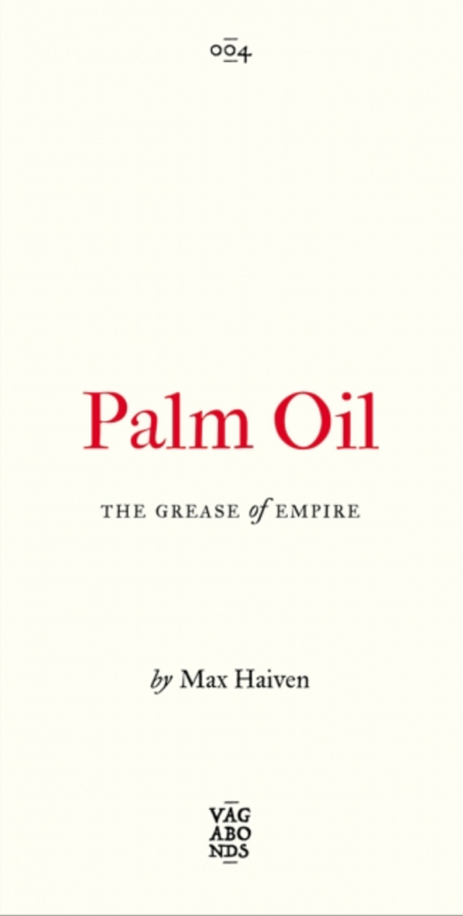
https://www.plutobooks.com/9780745345826/palm-oil/

